**Week-2**

1. Maximum Likelihood estimation
2. Gradient Ascent algorithm for learning Logistic Regression classifier
3. Choosing step size for gradient descent/ascent
4. Deriving the step-size of Logistic regression : Log trick
5. Deriving the gradient for the logistic regression
6. Summarizing learning linear classifiers   
   Quiz : Learning Linear classifiers

**Intuition behind maximum likelihood estimation**

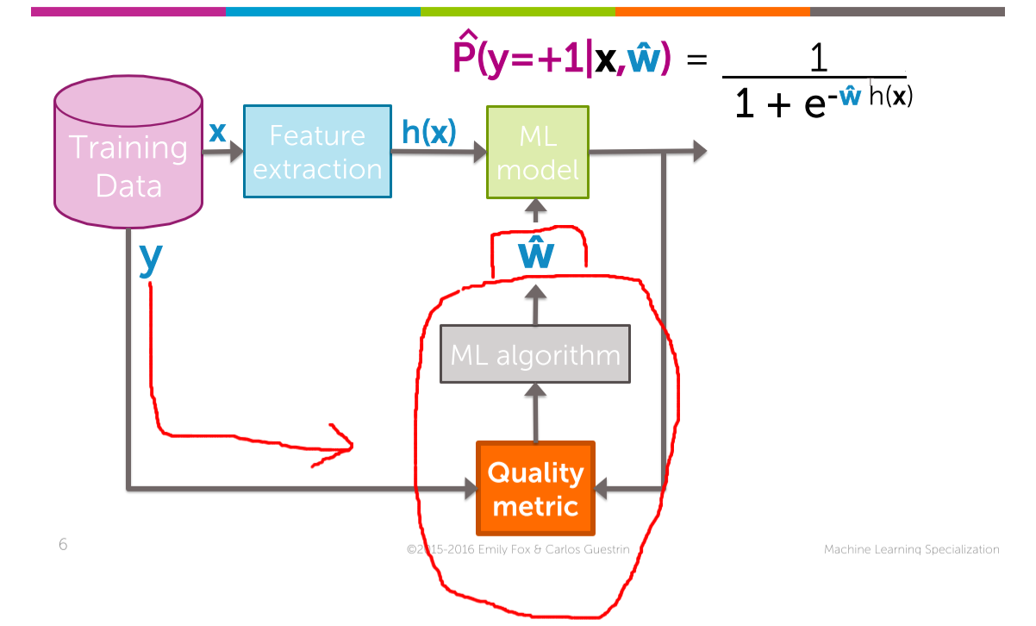



Our aim: To get the highest probability, but getting the highest probability depends upon the coefficient. Quality metric comes into the picture.

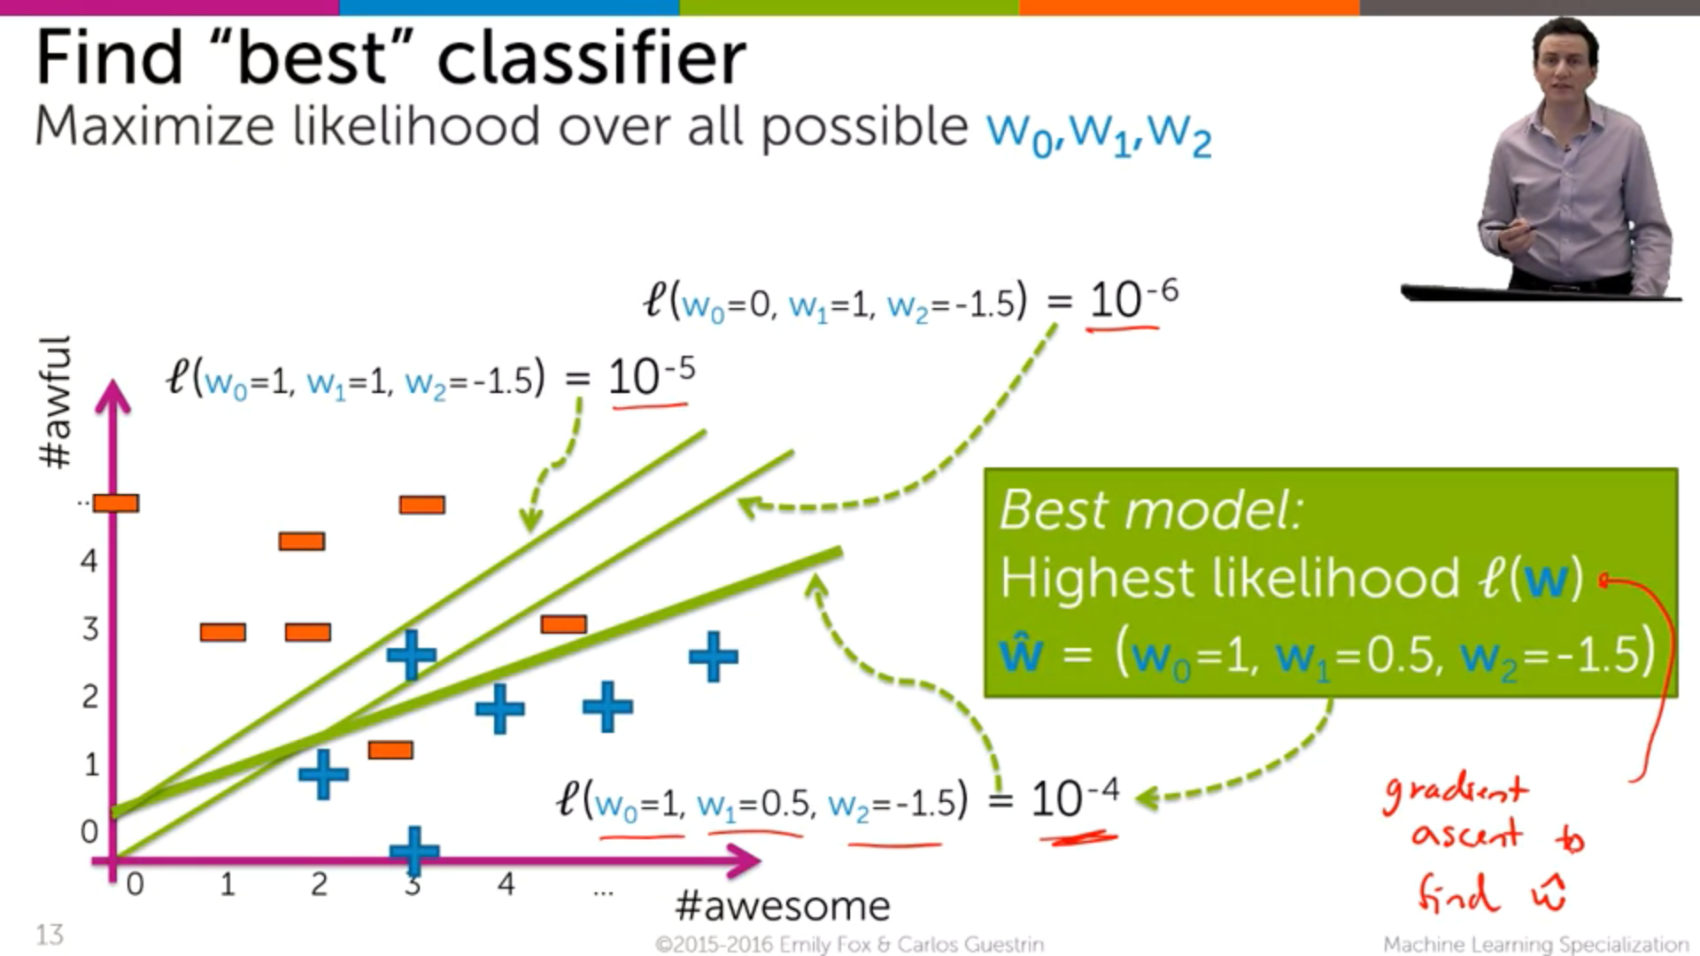

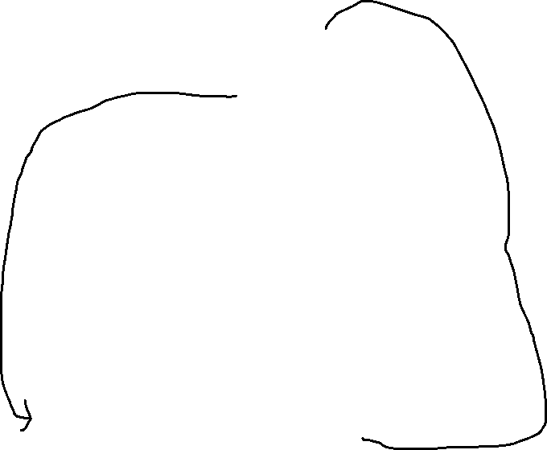

As the output of the likelihood function closely approaches to 1, the more perfect our model will be.

After that we have to find w^ which is done by Gradient Ascent



**Data-set**

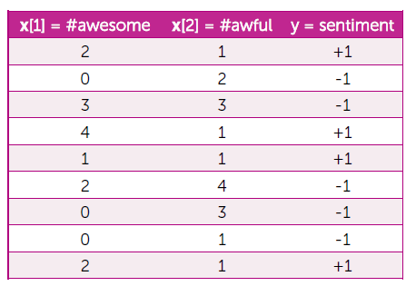

Separating based on +ve and -ve Sentiments

-ve Sentiments +ve Setiments



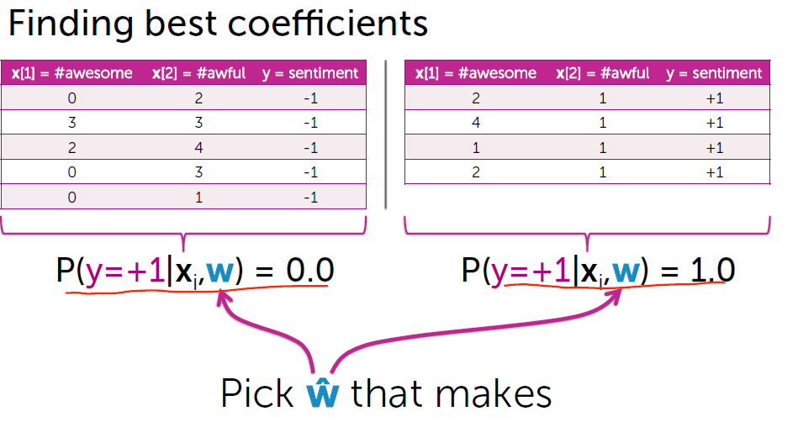

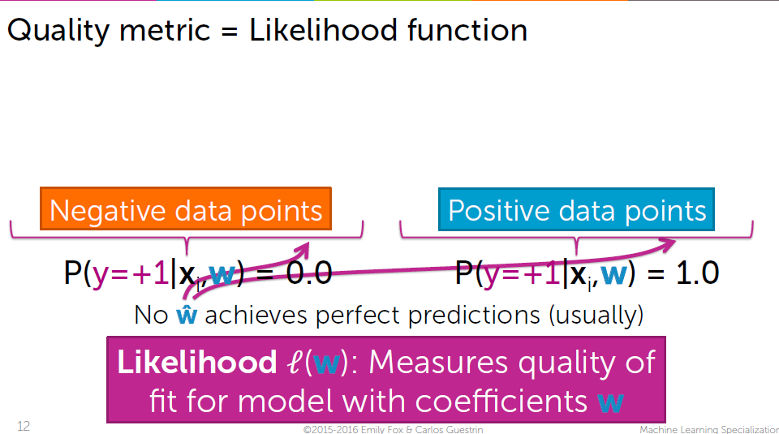

For +ve data-points 🡪 Probability is exactly close to 1 But There might be no exact w that



For -ve data-points 🡪 Probability is exactly close to 0 achieves 0 for -ve and 1 for +ve

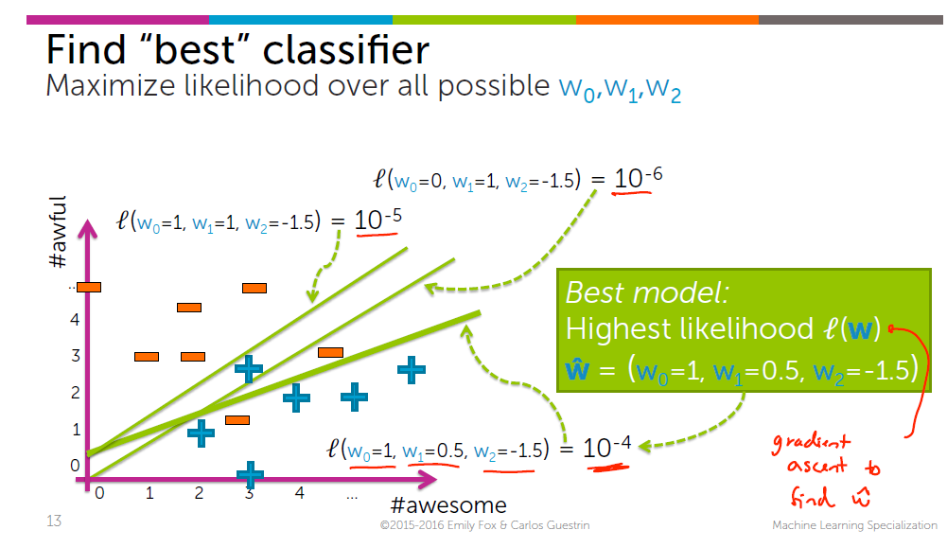

Best likelihood function l(w) 🡪 Should have maximum value. But we don’t know for which w^ is the likelihood function is maximum?? For that only **Gradient Ascent** comes to the picture

**Data likelihood**

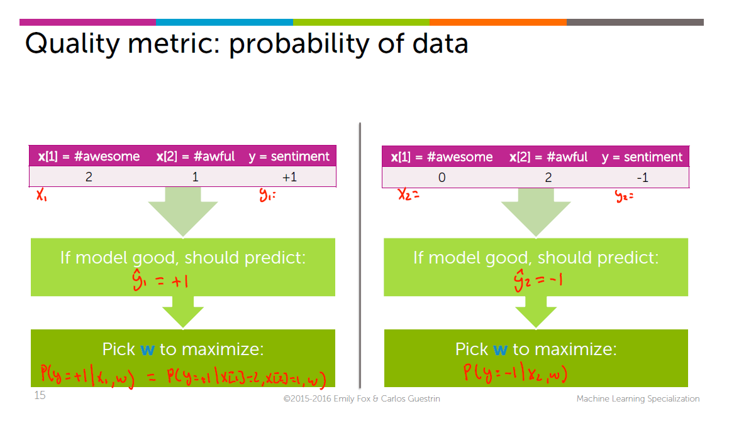

When the input 🡪 x1(positive example), we are going to maximize the P(y=+1|x1,w)  
When the input 🡪 x2(negative example), we are going to maximize the P(y=-1|x2,w)

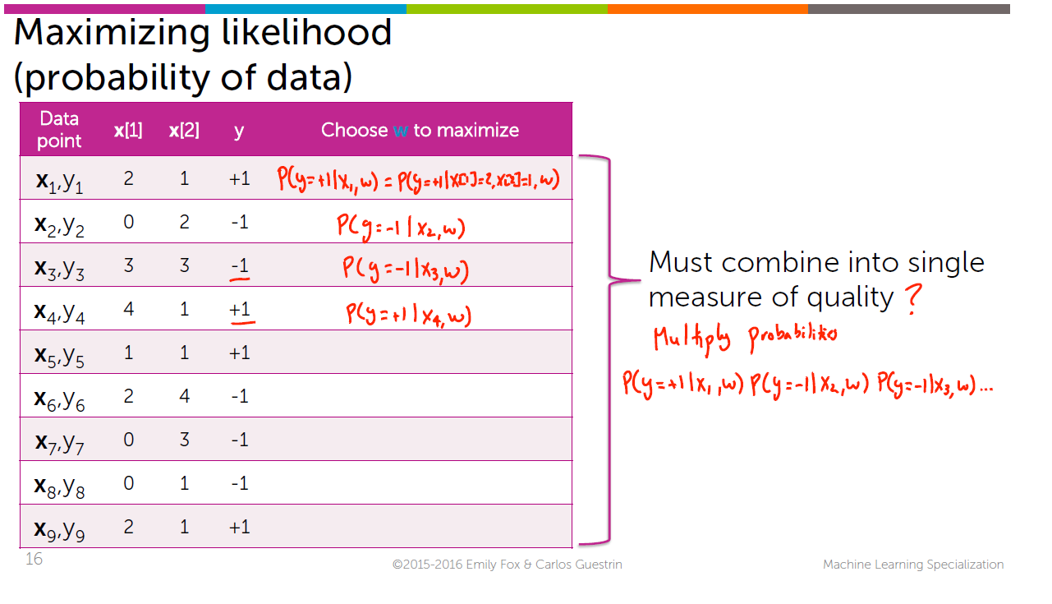

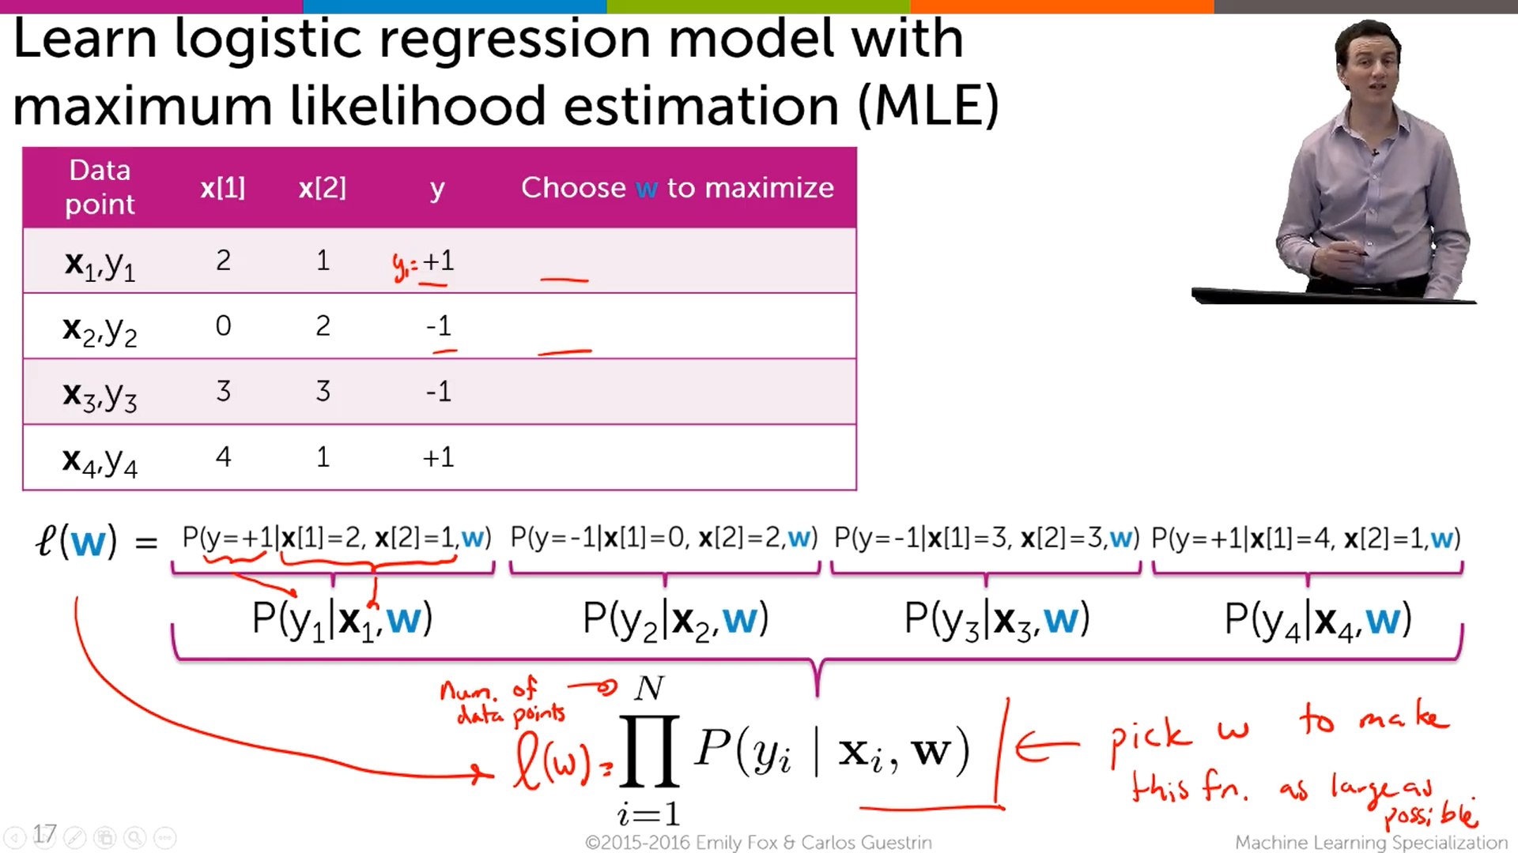



Multiplying all the probability, likelihood function

We want to pick a particular w for which the likelihood function l(w) 🡪 maximum.



This w is picked up by gradient Ascent algorithm



**Finding the best linear classifier with gradient ascent**

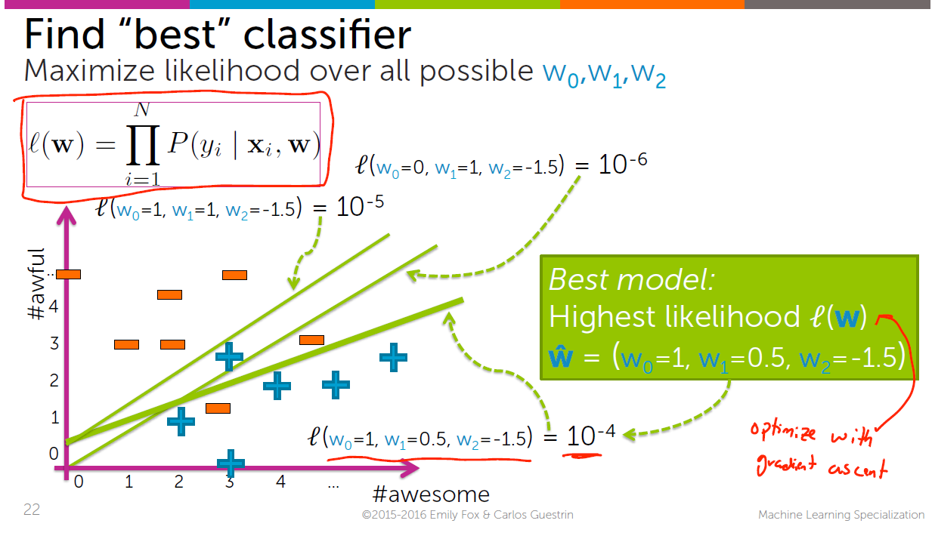

Our aim is to find the w^ using gradient descent, and for which w^’s the likelihood function is maximum.

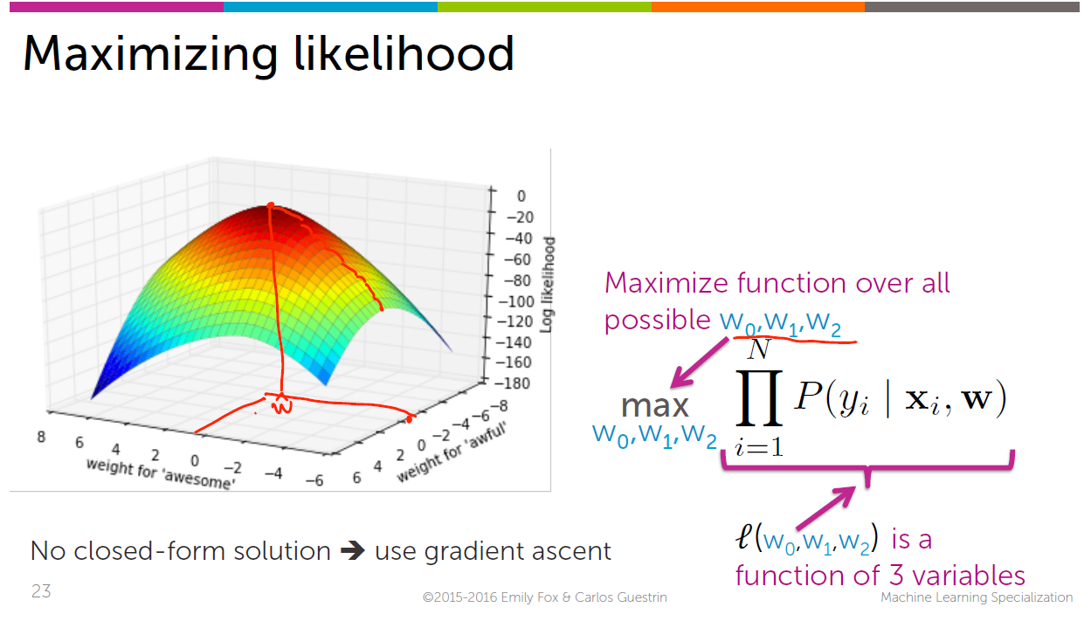

We want to reach the to top of the hill, With that maximum height (w^), we can get the corresponding w’s for each and every feature.

In the above figure it is drawn only for 2 features, since it is difficult to interpret/draw the w for the third feature.

***2) Gradient Ascent Algorithm for learning Logistic Regression Classifier***

**i)Review of Gradient Ascent**

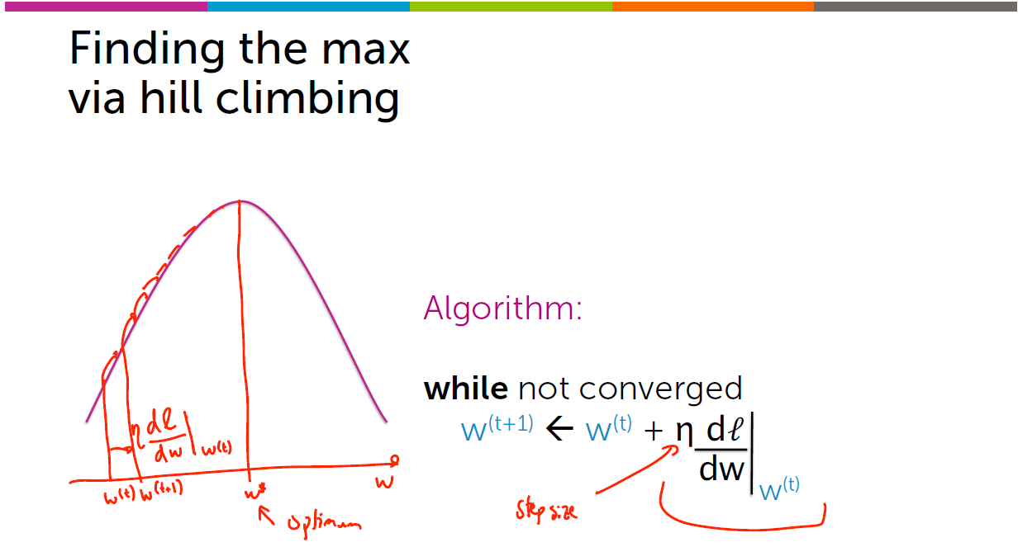

It is required to climb the hill to reach the top of the hill.

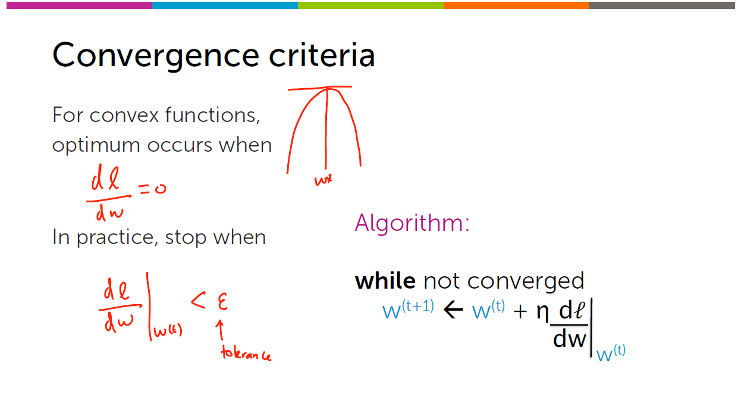

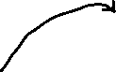

When the derivative(slope) = 0, then we can able to find the point at that maximum height. But we won’t get exactly. We are going to stop, when the derivative is smaller than the tolerance(epsilon). We will climb up and up until the derivative is sufficiently small. It is clear that we won’t able to approach exactly to the top but pretty closer to the top (i.e the w^).

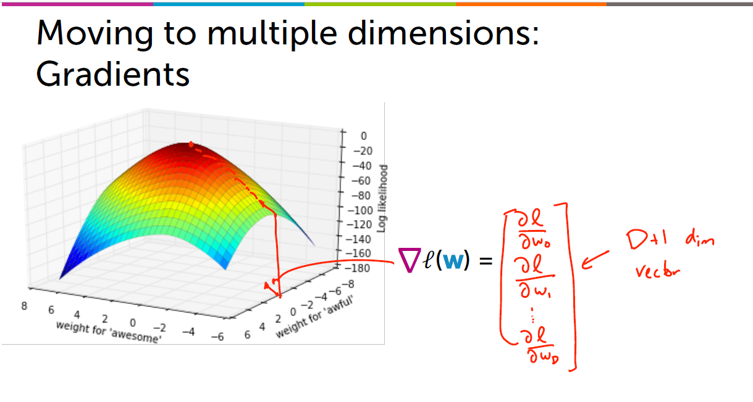

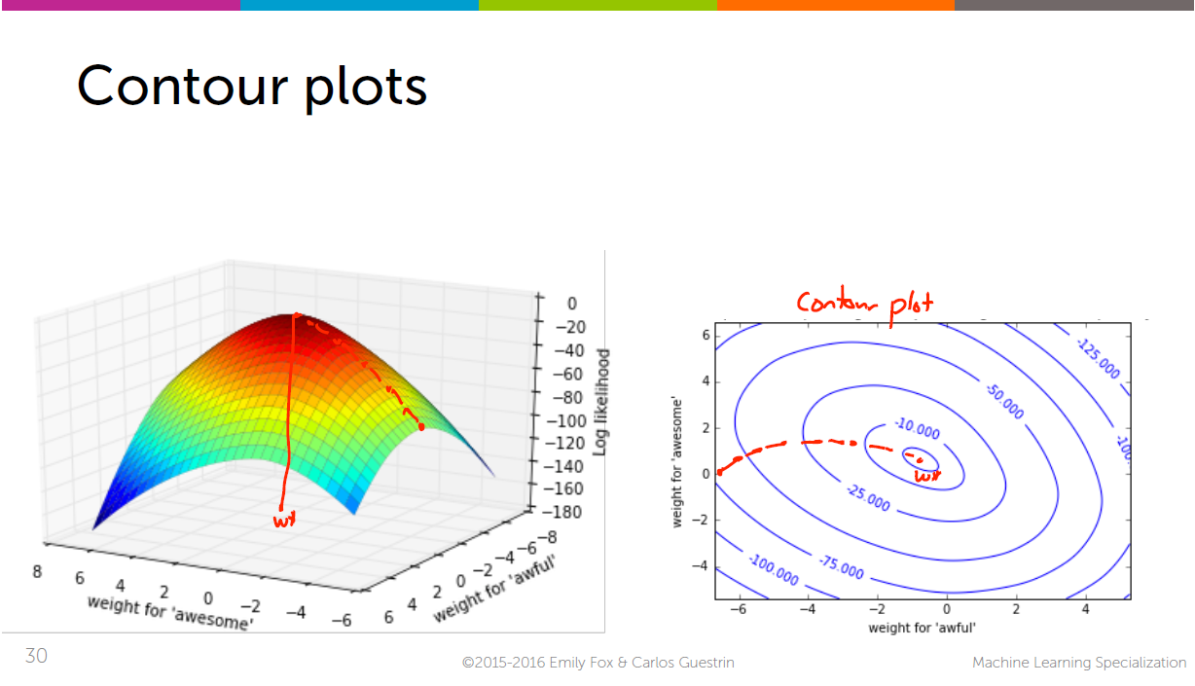



Both are same points

Visualizing the inner most part via contour plot.

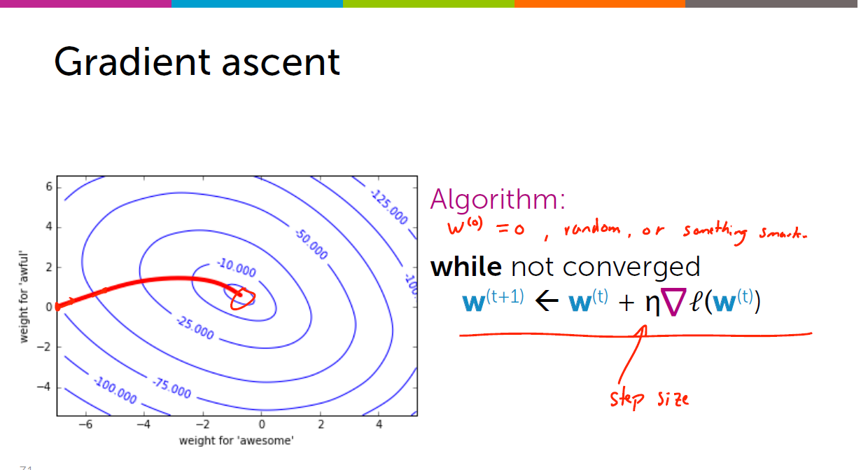

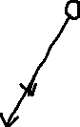

Remember Positive sign (Since we have to climb the hill)

**ii) Actual Learning algorithm for logistic regression**

Both the truth and the prediction is for +ve example.

Features How much my model predicts that xi is +ve?????

Eg(# of awesomes)

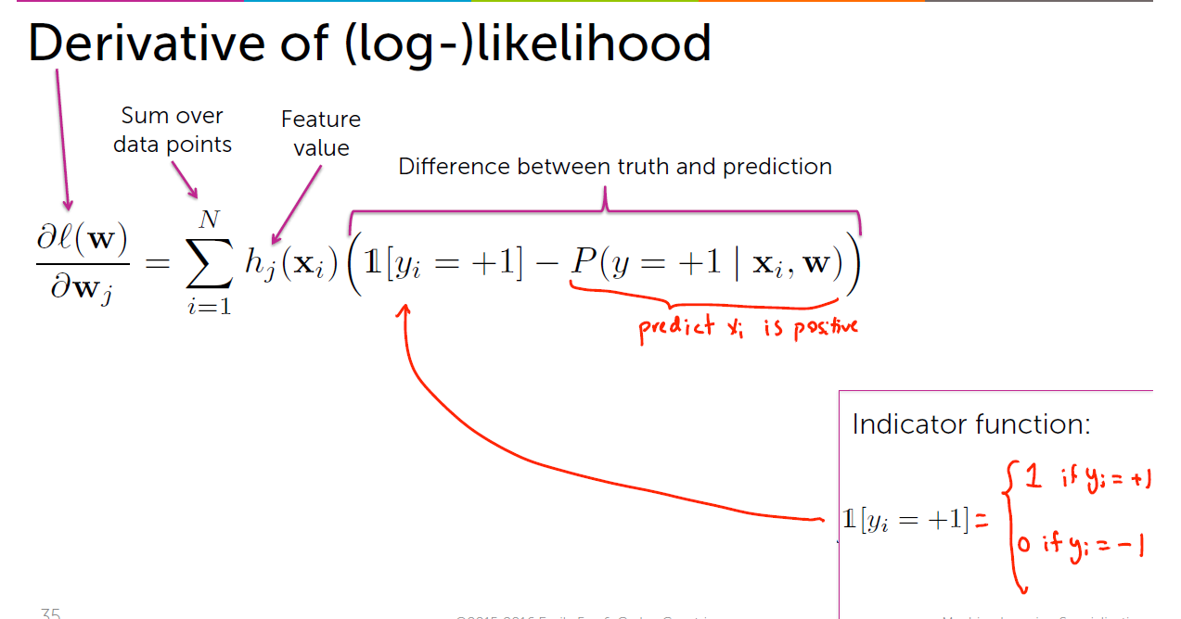



If the data-points has many-many awesome’ s (let 20) it has more contribution to the derivative. And the coefficients are multiplied by 20 awesome’s.

If the data-points has 0 awesome’s then there is no contribution, because even if the coefficients are higher/lower [ 0*coefficient 🡪 0]

**Awesome feature**

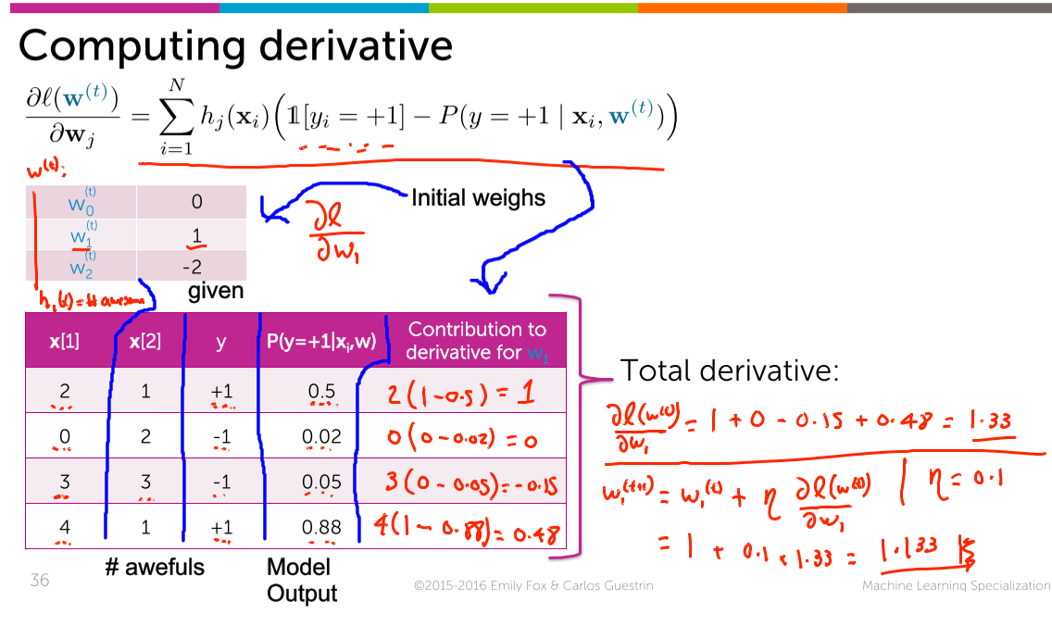

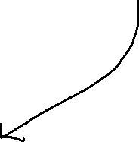

The predicted probability output is 0.02 (which is very-very close to 0). And the given value is also -1 🡪 Perfect Prediction.

**Is it possible to predict the derivative for x[2] (i.e awesome) ????**

We can’t predict for x[2](i.e awful) since the predicted P(y=+1 | xi,w) is given. But for awful we want P(y=-1| xi,w).

**iv) Interpreting Derivative for Logistic regression:**

**Taken : P(y=+1 | xi,w) [ Expecting positive probability]**



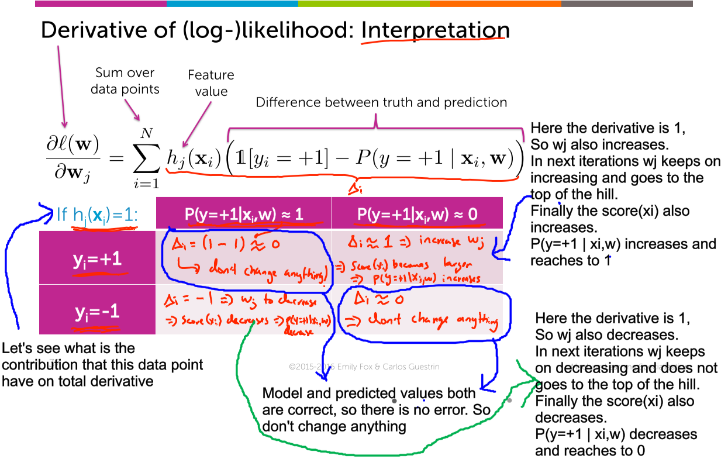



(Slope doesn’t change)

1)derivative 🡪 (1-1) 🡪 0 (Observed=predicted)  
2)derivative 🡪 (1-0) 🡪 1  
3)derivative 🡪 (0-0) 🡪 0 (Observed=predicted)  
4)derivative 🡪 (0-1) 🡪 -1

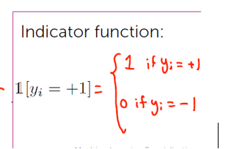

For -ve data-points, we get wrong, we decrease the coefficient to make the probability of it being positive smaller and thereby increasing the probability that , that data-point will be -ve.

So for the Positive probability   
🡪+ve training data-point, the coefficients are pushed to the top of the mountain  
🡪 for -ve training data-point, the coefficients are pulled down to the bottom.

**v) Summary of Gradient Descent**

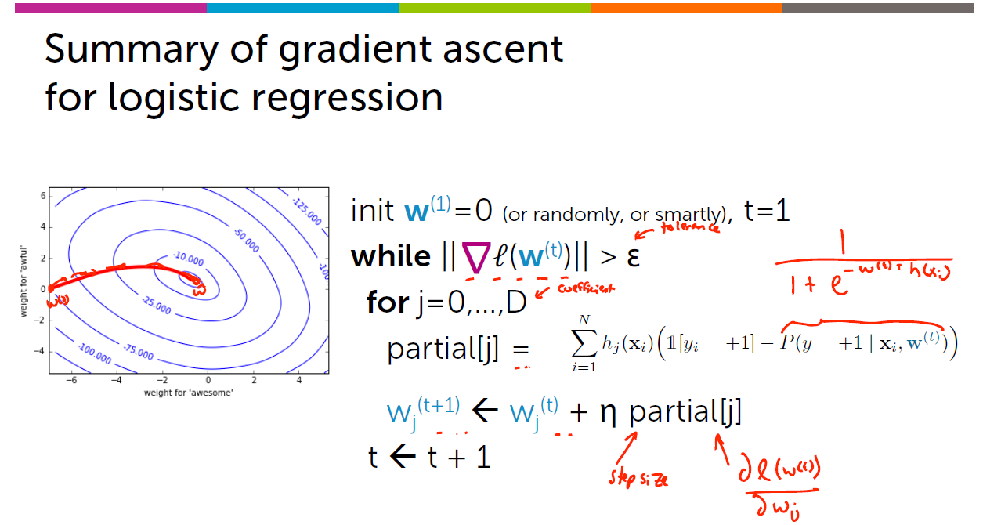

partial[j] 🡪 classification 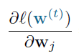 (Differentiating the likelihood junction with respect to w

partial[j] 🡪 regression 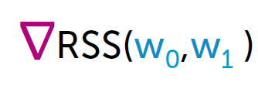 (Differentiating the Residual sum of squares with respect to w

**3) Choosing Step-size for Gradient Descent/Ascent**

**i) Choosing the step-size:**

**Aim 🡪 To attain larger values of likelihood function with lesser number of iterations.**

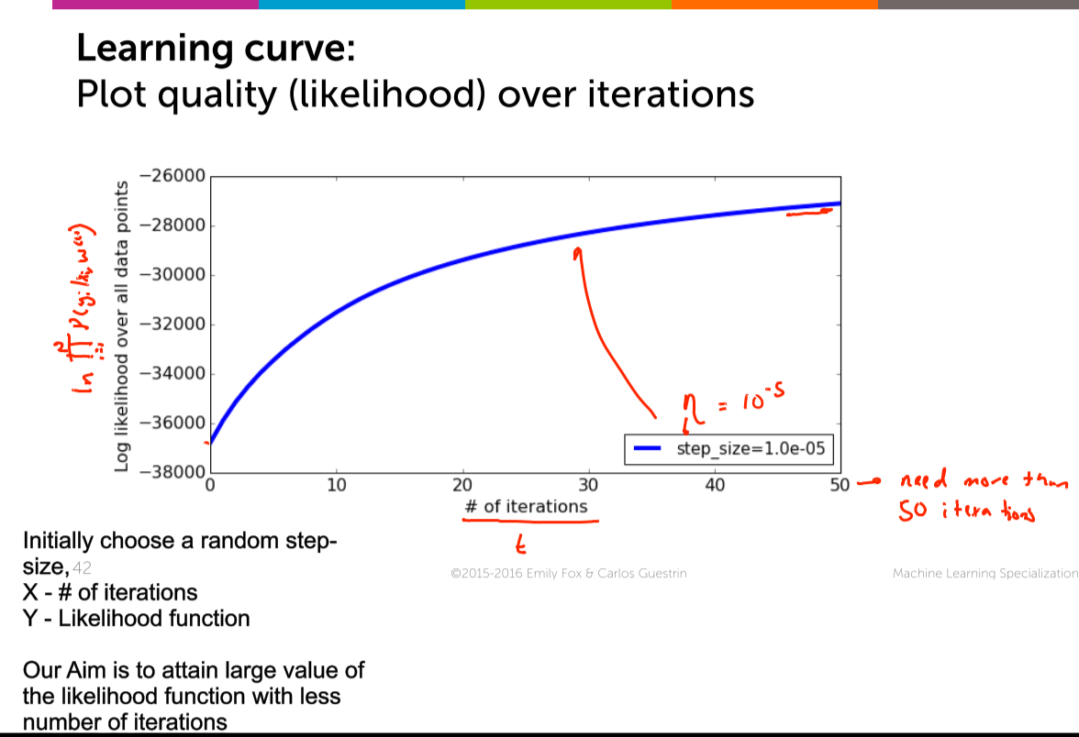

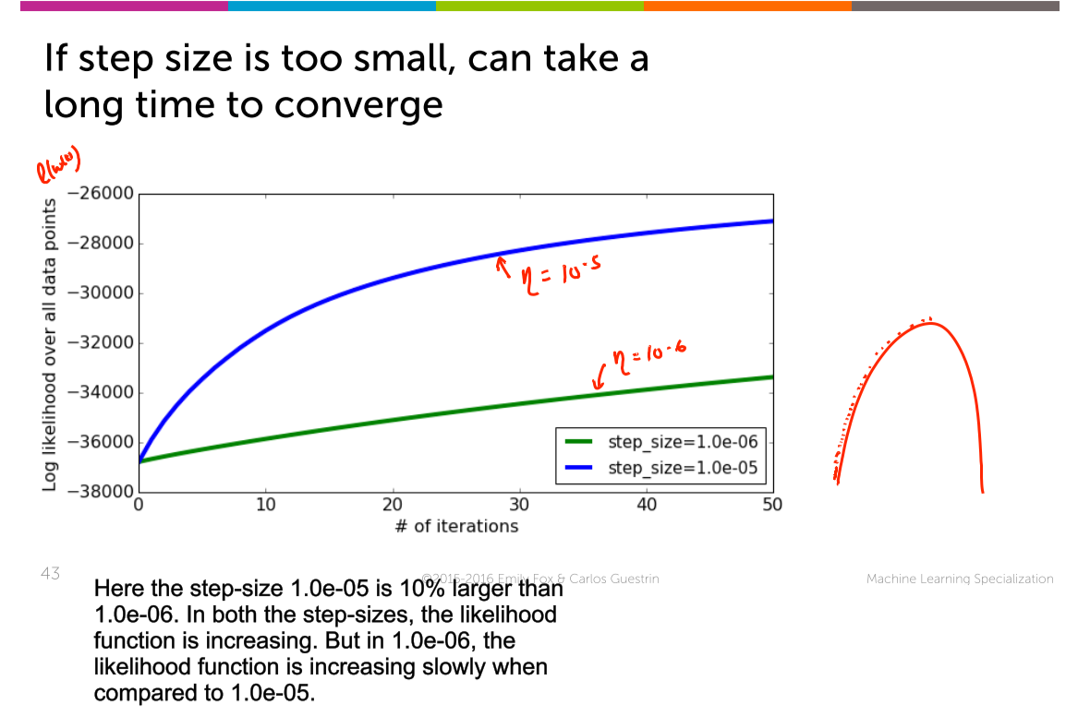

Smaller step-size 🡪 More time

Larger step-size 🡪 Less time

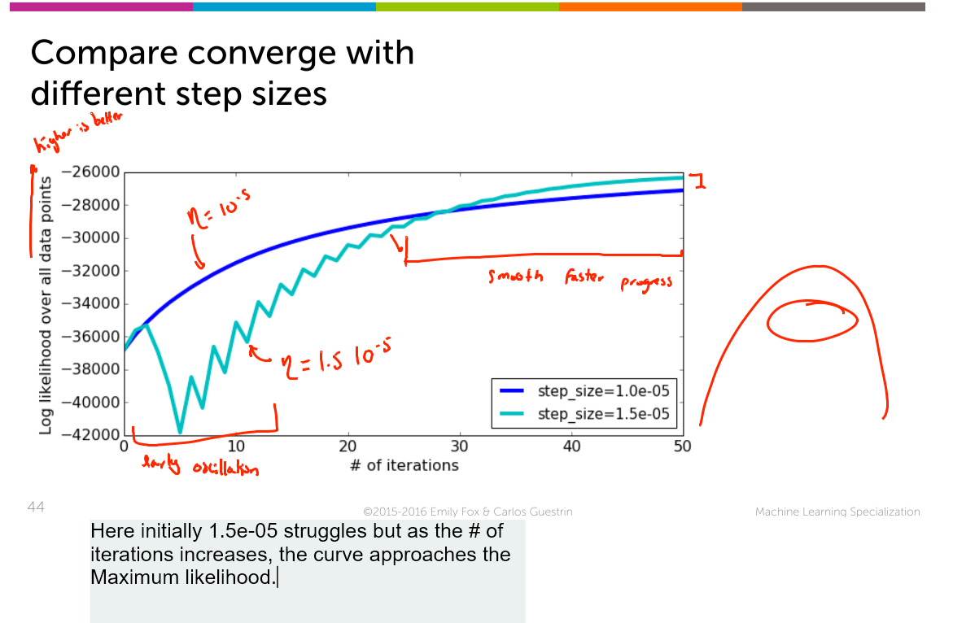

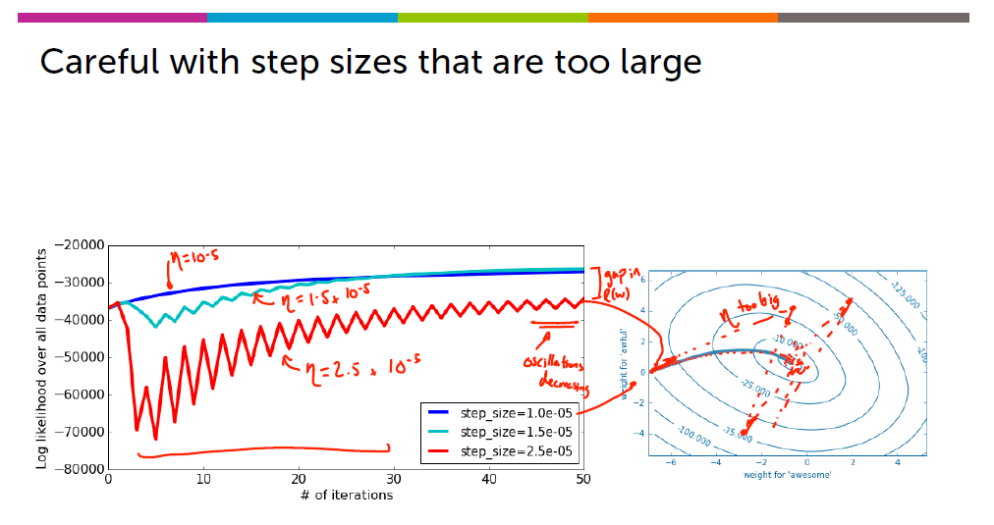

Here =2.5*10^-5 takes larger step-size, and goes back and forth continuously, and finally comes near to the top of the hill.



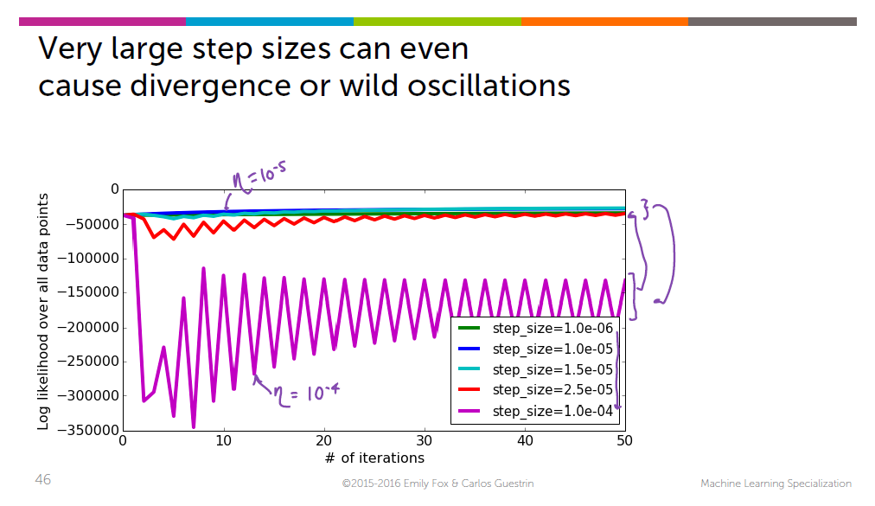

10^-4 🡪 also larger step size and takes many iterations to reach the top of the hill.

Now we learned that 10^-6 🡪 too small and 10^-4 🡪 too big, Now we are having a finite range to search for the step-size.

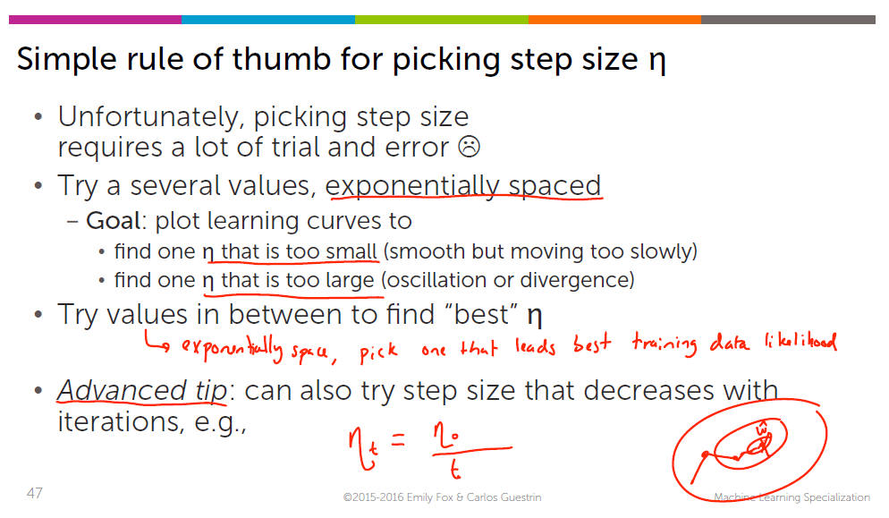

***4)Deriving the gradient of logistic regression :***

i) Deriving the gradient of logistic regression : log trick

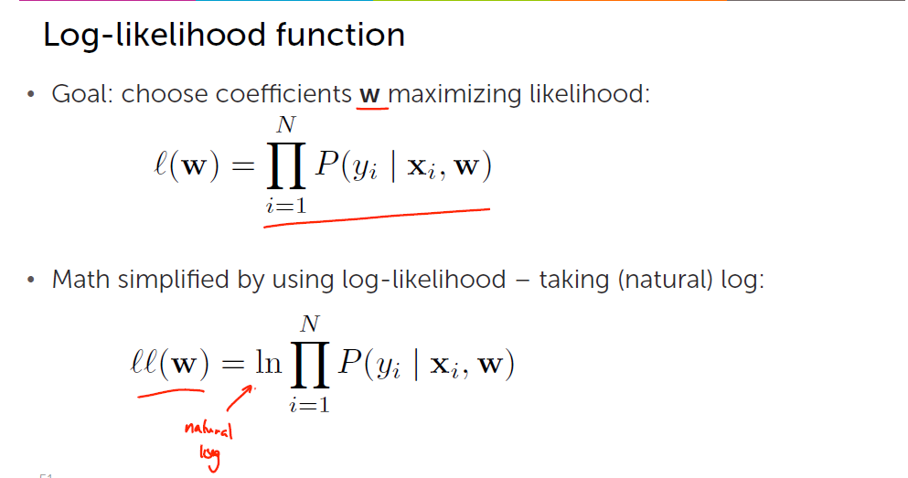

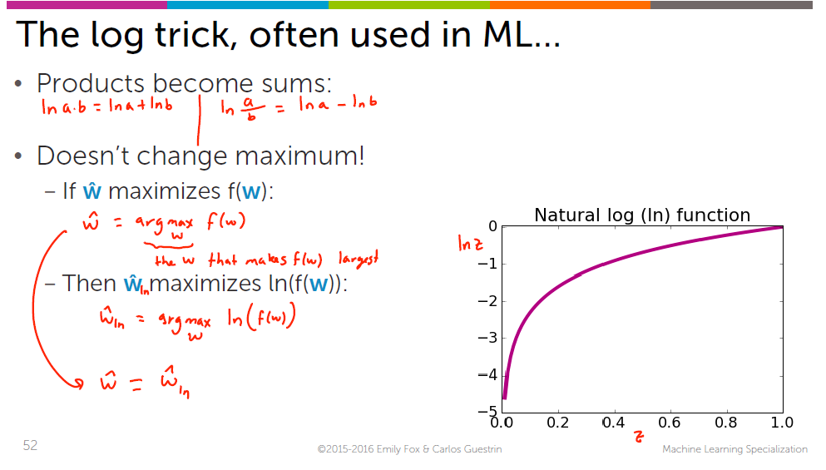

ii) Express the log likelihood function

log of the products = log of the sum

Before applying log, the derivative of the product 🡪 So complicated   
Now the derivative of the sum is just the sum of all the derivatives 🡪 Very easy

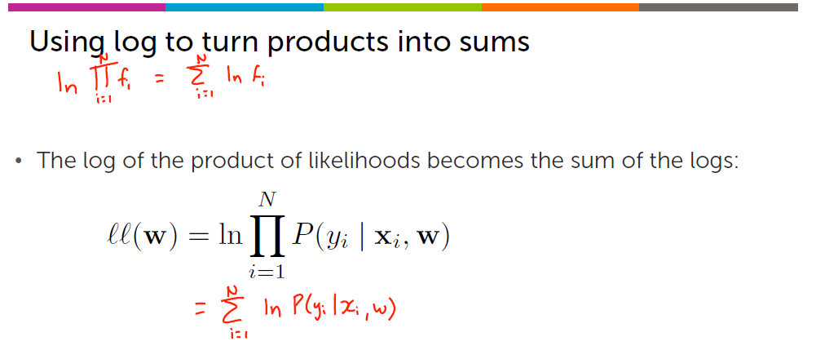

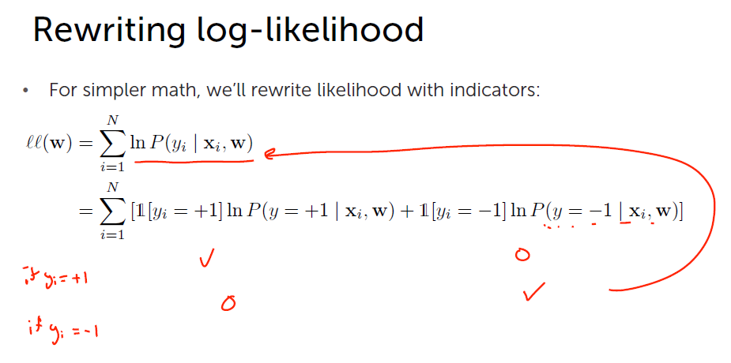



ii) Deriving the P(y=-1) |xi

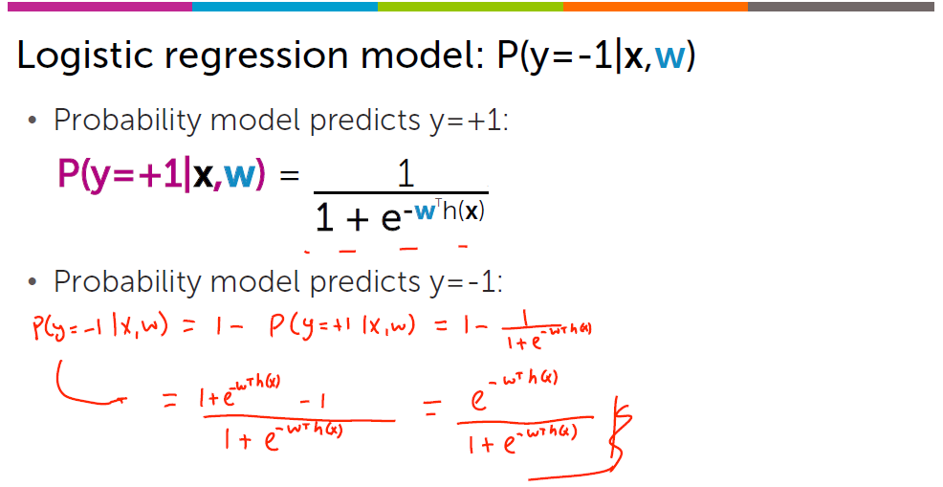



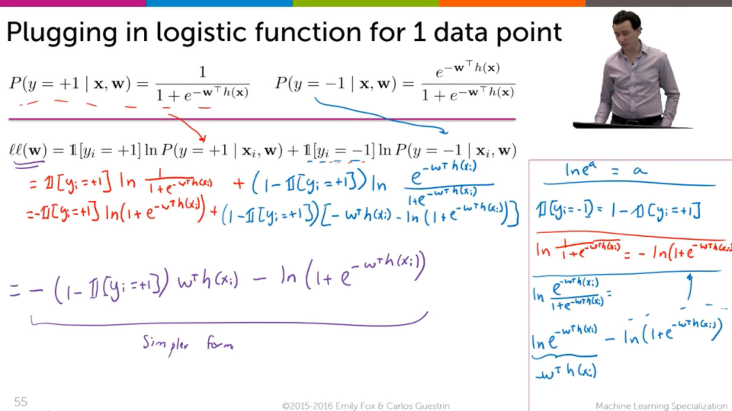

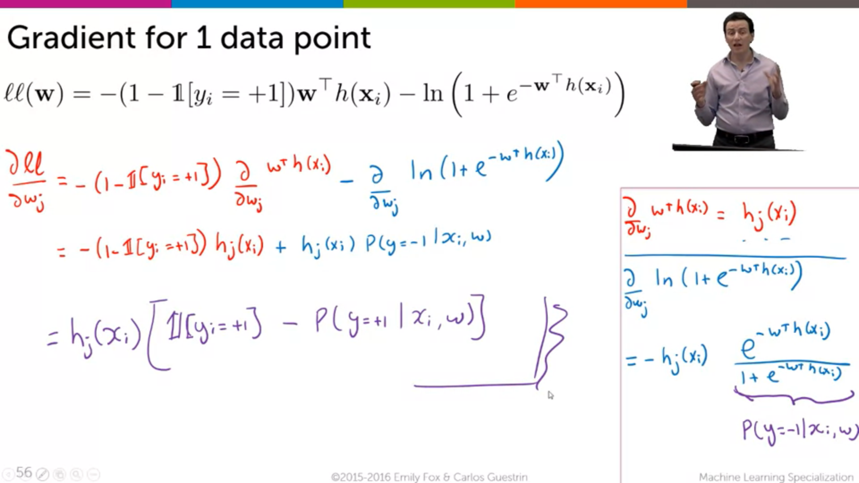

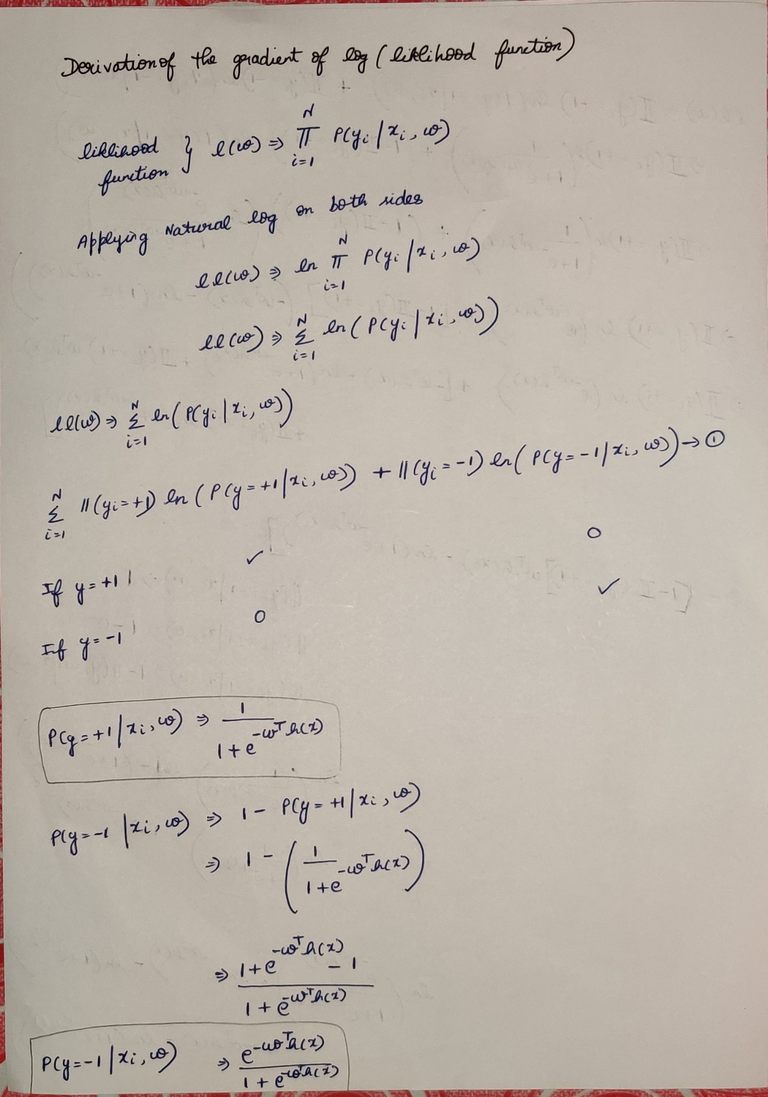

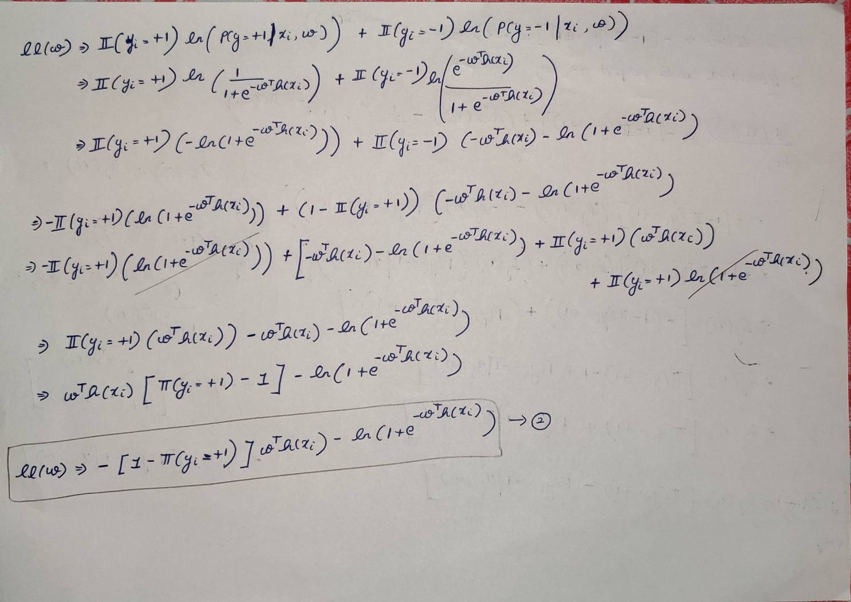

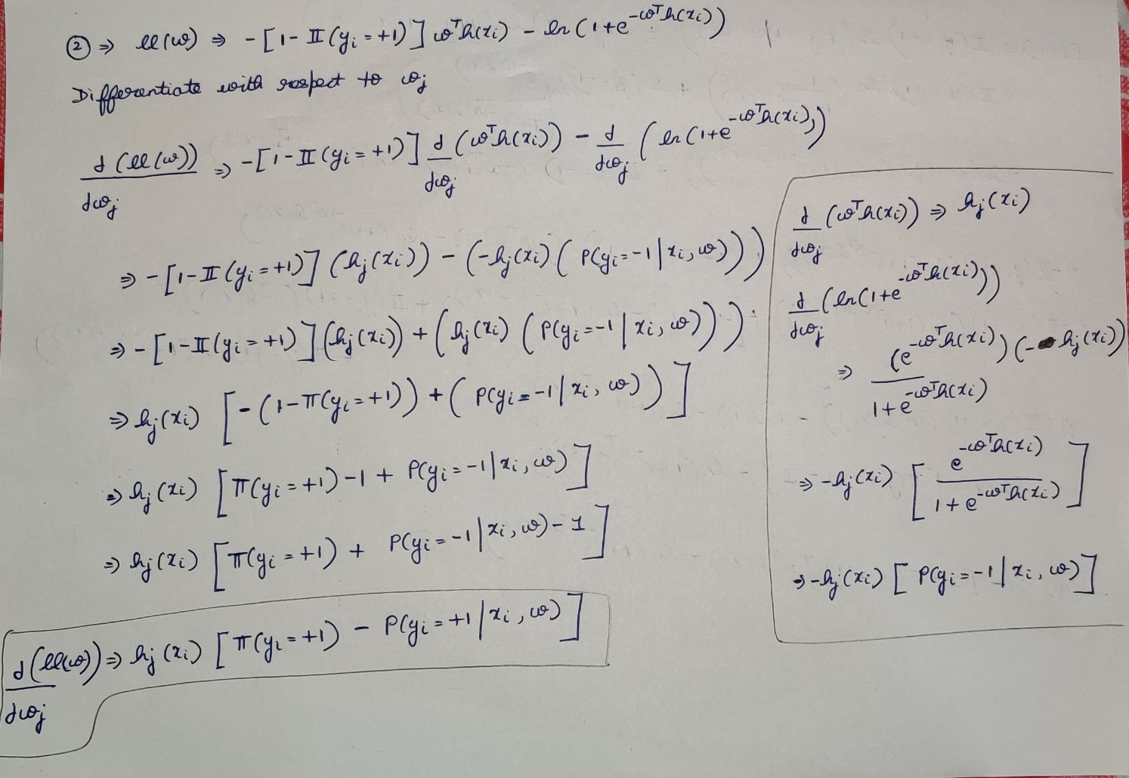

For the data’s having only one independent feature:

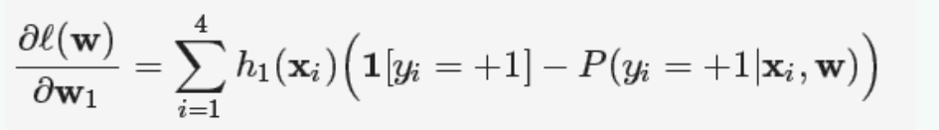



Reference :

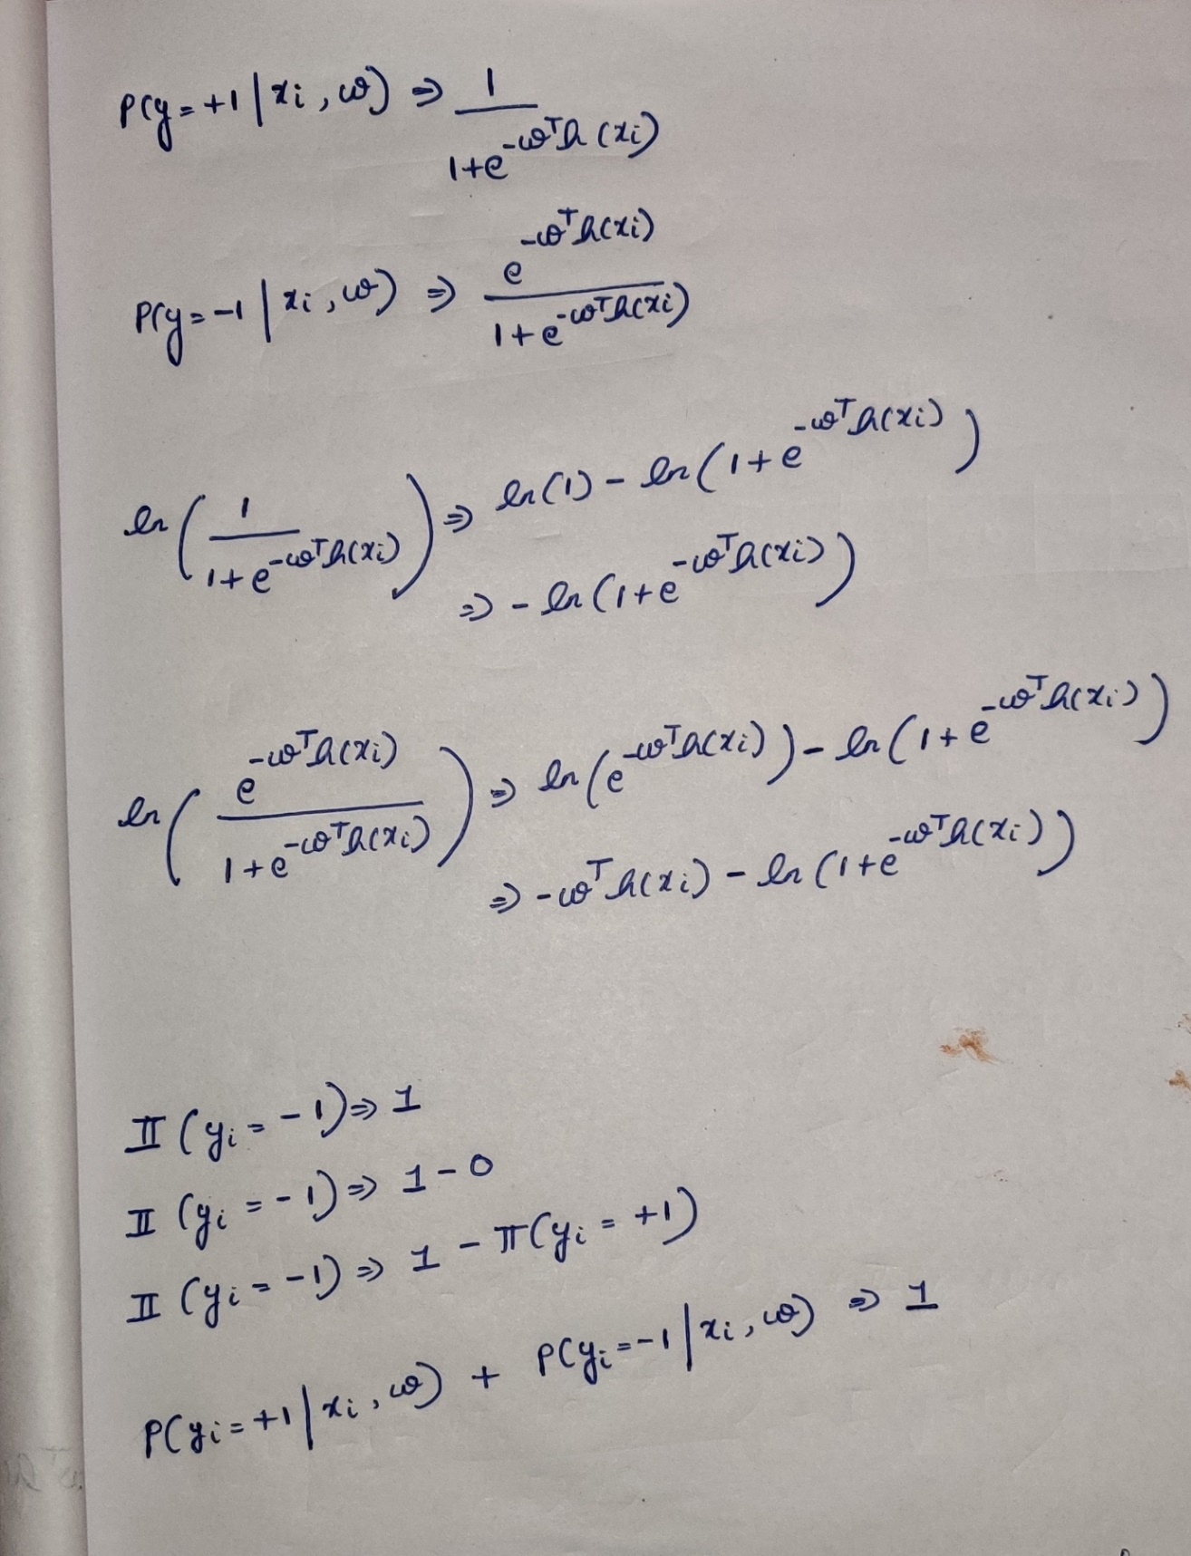

***6)Summarizing learning linear classifiers***

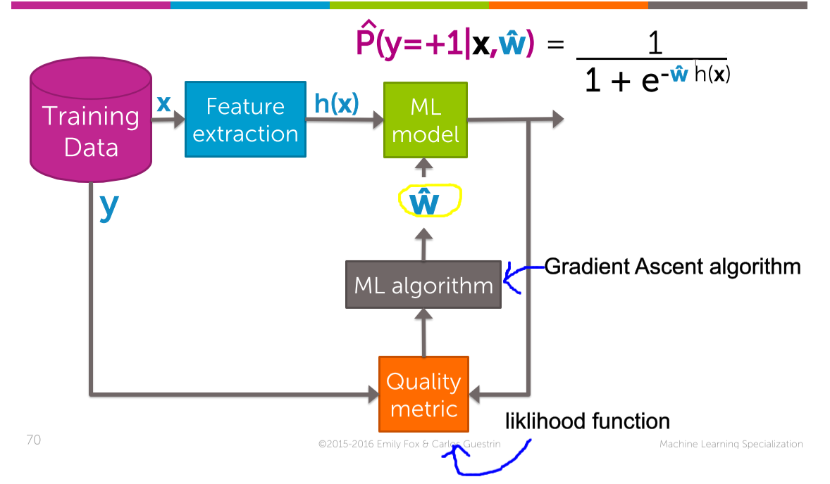



**Quiz questions :** 